**Software Development Life Cycle**

**End to end development of an application or Project steps.**

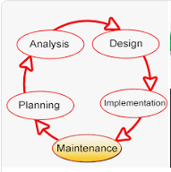

Old methodology: **WATER MODEL Methodology**.

1. Gathering requirements from Client . (3 months projects, client Jan 1 st)
2. Planning (Jan 2nd to Jan 15th )
3. Analysis (Jan 16 to Jan 31)
4. Design (Feb 1 to Feb 15)
5. Development (Feb 16 to March 1st)
6. Testing (March 2nd to March 15th)
7. Client Demo ( March 20th) ---- if any change in project or client didn’t like the product. Production deployment will be impacted. Repeat from Step1 to Step7. with this project timelines has increased to another 2 months.overall project timelines are 5 months.
8. Production Deployment (March 31st)

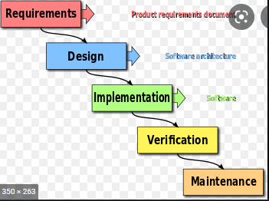

To avoid development time and issues of Water fall methodology, Agile is introduced to the industry.

Agile Methodology :

The Agile methodology is **a way to manage a project by breaking it up into several phases**. It involves constant collaboration with stakeholders and continuous improvement at every stage. Once the work begins, teams cycle through a process of planning, executing, and evaluating.

**Project Requirements given by Client (3 months)**

Client Demo (Jan 20th)

Client Demo

Client Demo

Release Jan 31st

Release Feb 28

Release march 31st

**Project Live(March 31st)**

Testing (Jan 7th to Jan 15 th)

Testing

Testing

Development (jan7th to Jan 15h)

Development

Development

Planning & Design

Planning & Design ( Jan 1t to Jan 7th)

Planning & Design

Phase 2 (PI)

Phase 3 (PI)

Phase 1 (PI))

Agile Team :

Product Owner (Client)

Scrum Master

Developer

Tester (manual&automation)

System Analyst

Domain Experts

Project Manager

This team will meet everyday on a daily stand call to update their progress of work completed fr that day.

* What you did yesterday?
* What you are going to do today?

**Agile Structure:**

**Requirements:**

1. **PI ( 12 weeks work)**
   1. **Features ( Capabilities) ( 1 sprint work)**
      1. **User Stories ( 1or 2 days work)** 
         1. **Developer or Tester has to give the story points to the user story based on criticality.**
         2. **Every user story has few states.**
            1. **Backlog**
            2. **Grooming**
            3. **Defined ( with Detailed work notes and valid Acceptance criteria)**
            4. **In progress (Developer/Tester)**
            5. **Completed**
            6. **Accepted ( PO will approve or accept the user story after having a Sprint Demo)**
         3. **Tasks ( hours work)**